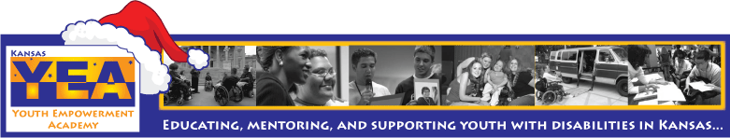
Kansas Youth Empowerment Academy Newsletter
In This Issue  Behind Julia's Glasses  KYEA News  Featured Youth  Question of the Month  State News  National News  Scholarship  Internships  Quote of the Month  Photo of the Month  PRIDE. Two '09 KSYLF alumni, Herschel Funk and Megan Allen, join KYEA staff for a presentation at North High School in Wichita. | Issue: #15 December/2009
Dear KYEA Family and Friends,


Happy Holidays! As we celebrate this season, we are reminded of all of the gifts that KYEA has been given in the past year... a solid team of wonderful staff, 24 new KSYLF alumni added to our KYEA family, growth and creation of new programs, the passage of a Disability Awareness and History Bill in Kansas, the continual support from our community partners, and so much more! Not only do we reflect on our gifts, but we look towards a new year with excitement of what 2010 will bring for KYEA. This will be our last issue of the year, so we have worked to bring you an informative, yet fun and interesting, newsletter. Our goal is to create a newsletter that you, our supporters, WANT to read. So, enjoy the issue, and enjoy the season!
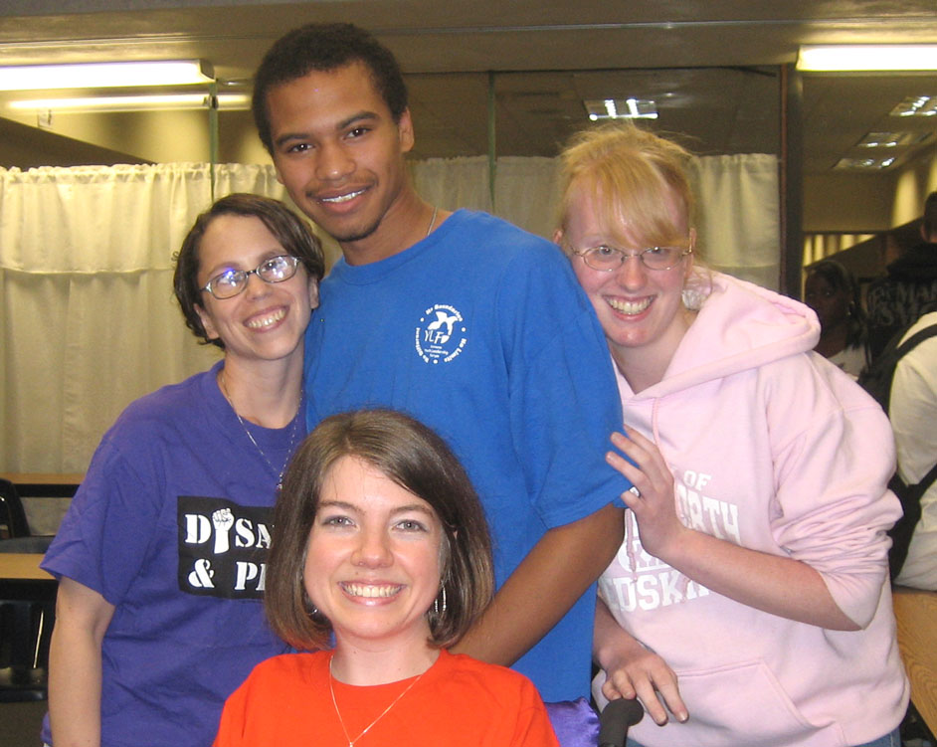 | BEHIND JULIA'S GLASSES  Thoughts from Executive Director, Julia Thomas
Ever since I was a child, I've always worn glasses. Not the high fashioned glasses, but the Coke bottled glasses that are magnified. People always seem to be curious and ask me, "Can I try on your glasses?" Because I was self conscious about my glasses, the answer was always "no." Since KYEA works to break down fear, it is now my turn to break down my wall, and give you a peak of how I see the world "Behind Julia's Glasses."
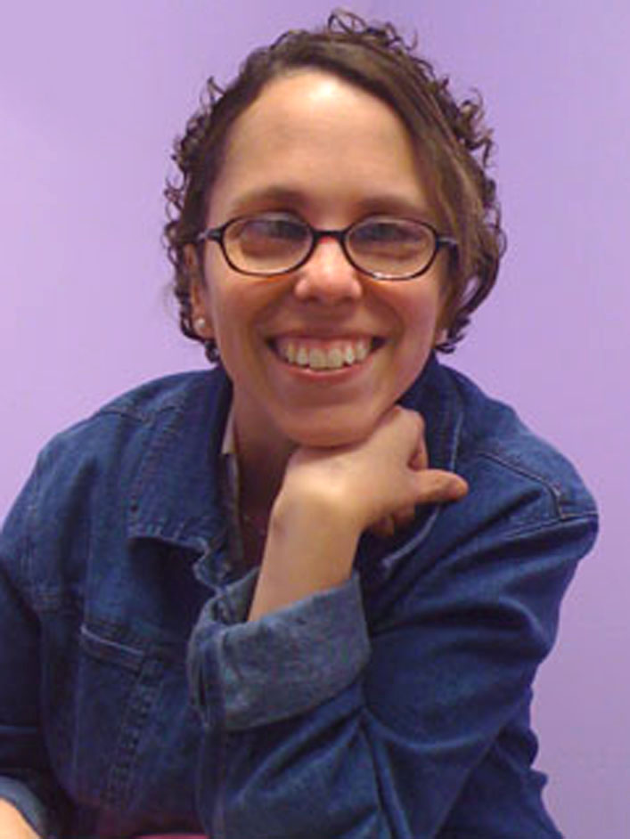
Beginning on November 1, we all start to think about the holiday season and know that it means joy, happiness, giving, and loving one another. This season is about food, family, fun, and, of course, presents! No one tells us that we have to act this way because of the holiday season, we just know. Then why is it, when the first snow falls, people are grumbling? Or after Thanksgiving dinner, we complain about having to work out because we eat so much? Waiting in long store lines is never fun, but even to get there, you need to push people out of the way to get that sale. I don't know about your dictionary, but my dictionary does not define this as happiness.

There is always a good side and a bad side to everything. Why, then, when it comes to our disability, do we look at the bad side first? Why can't we just KNOW that having a disability can be a year round season of acceptance if we want it to be? Yes, it may take us longer to do things, and we may look different doing them, but what a feeling of accomplishment when we meet a goal. If people believe in a jolly man who drives a sleigh full of reindeer, why is it so hard for us to believe in ourselves?

One way Santa knows that all his gifts will be delivered in one night is because he has amazing supporters at work (the Toy Factory), at home (Mrs. Claus), and an awesome navigation system. So why can't we follow in Santa's footsteps? Surround yourself with people who believe in you... at home, at work, or wherever you may be. And while you're at it, spread this message of hope to ALL people with and without disabilities. And if people ask you who you heard this from, tell them a girl with glasses told you!

KYEA On the Web

www.kyea.org

www.myspace.com/ksylf
Check out these other websites!

National Sports Center for the Disabled- www.nscd.org

College Prep Checklist-http://studentaid.ed.gov/PORTALSWebApp/students/english/checklist.jsp

Teens Against Bullying-teensagainstbullying.org

Personal Leadership Insight-
Personalleadership
insight.org

Kansas Mentors-kansasmentors.
kansas.gov
Join Our Email List

To receive our newsletter through email, contact us at carrieg@kyea.org or 785-215-6655.
 | KYEA NEWS by Carrie Greenwood
KYEA youth intern position still open and available!
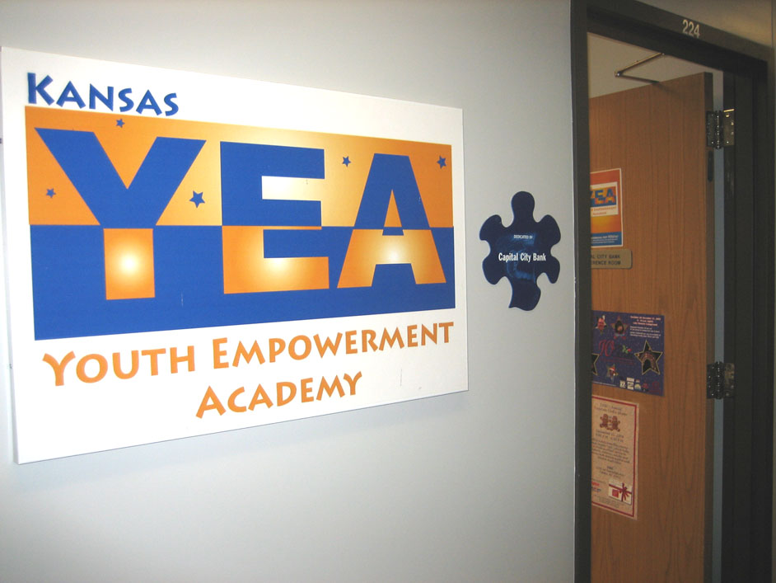
Do you have an interest in working for the Kansas Youth Empowerment Academy? Are you a youth with a disability who is looking for some employment experience? Then we encourage you to apply for our KYEA youth internship!

The person who is chosen to participate in our internship program will have the opportunity to assist with KYEA programs and other office tasks, while also learning various employment skills. They will be exposed to a working and learning environment. This internship is a temporary, five month position of 10 hours a week. The intern will receive a stipend of $80 per month and will work in the KYEA office, which is located in Topeka, KS.

If you have an interest in our KYEA mission and would like the opportunity to be a part of our team, then this is your chance! Not only will you be assisting KYEA, but you will be learning employment skills that will help you in future jobs.

To apply for our internship, please contact the KYEA office at 785-215-6655 or email juliat@kyea.org.

The Kansas Youth Empowerment Academy is made possible through a grant from Kansas Rehabilitation Services.
KYEA NEWS (continued)

KS Youth Leadership Forum applicant deadline extended
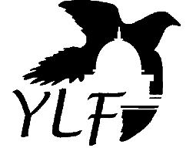
It's that time again! KYEA is currently searching for potential youth leaders to attend our 10th annual Kansas Youth Leadership Forum for Students with Disabilities (KSYLF). Any students who are interested in attending the KSYLF this summer, but have not yet sent in their applications are in luck! We are extending our delegate application deadline to January 15, 2010.

The 2010 KSYLF will be held June 8-12 at Washburn University in Topeka. The KSYLF is a motivational five day forum in which a group of students gather to learn about leadership development and disability pride. During the forum, delegates enjoy a week full of learning, fun, friends, and, most of all, a new sense of empowerment! Through various large sessions, delegates are able to hear from community leaders on such topics as disability history, advocacy, goal setting, leadership, resources, and much more. Students are also able to share life experiences, goals, and ideas during breakout sessions with small groups. Delegates participate in fun activities as well, such as a Day at the Capitol, Mentor Luncheon, recreation session, real life fair, and a barbecue. A talent show and dance, which are always delegate favorites, are also a part of the week!

All students who are interested in attending the KSYLF must meet the following criteria:
- reside in Kansas
- have a disability as defined with the Americans With Disabilities Act
- be in the 11th or 12th grade as of December 31, 2009
- have demonstrated leadership potential in school and the community

Students must fill out an application that will be reviewed through a competitive selection process. About 30 - 40 delegates will be selected to attend. Applications can be obtained by emailing KYEA at carrieg@kyea.org. Remember, the extended application deadline is January 15, 2010. To learn more about the KS Youth Leadership Forum, visit www.kyea.org/content/view/37/56.

Volunteers needed for 2010 KS Youth Leadership Forum
Calling all former and potentially new volunteers! KSYLF is now accepting applications for volunteers for our 2010 KS Youth Leadership Forum. We are searching for committed, enthusiastic people who are willing to devote a week to this great program. Do you have the skills and passion to facilitate groups and motivate youth with disabilities? Then consider serving as a volunteer at the 2010 KSYLF to be held in June.

The goal of all facilitators is to empower and support each delegate as they discover inner strengths and abilities as individuals and as members of a group. Volunteers are assigned to work with a small group throughout the week. They also interact with the large group during many activities. Volunteers must stay on campus for the duration of the week that KSYLF is taking place.

Past volunteers, KSYLF alumni, and new volunteers are encouraged to apply! Volunteer applicants must fill out our application form, as well as two background checks, and send to the KYEA office by February 5, 2010. Applications can be obtained by emailing KYEA at carrieg@kyea.org.

Justin Cosco Scholarship Award seeking nominations
Each year, KYEA selects a recipient of the Justin Cosco Scholarship Award. The award begin in 2004, but was renamed in 2007 after the death of an alumni of the first Kansas Youth Leadership Forum, Justin Cosco. This award is given to an alumni who has demonstrated progress toward their goals and growth as a leader. The following are requirements to receive this award (each nominee must meet one or more of these requirements):

- Be a KSYLF Alumni from the years of 2001-2008. (required)
- Have demonstrated leadership skills and accomplishments.
- Be in the process of completing and/or have completed the KSYLF Personal
Leadership Plan.
- Have used community resources to pursue leadership goals.
- Be willing to participate in post KSYLF organizations/activities.

Alumni can either nominate themselves or be nominated by someone else. Nominations are due by April 1, 2010. One winner will be chosen and notified by May 1, 2010. The winner receives many benefits including a small financial scholarship, as well as a scholarship to the 2011 Kansas Disability Caucus, a plaque, recognition at the 2010 KSYLF Mentor Luncheon, and more!

PRINT THE NOMINATION FORM - www.kyea.org/content/view/152/115

New peer group in Topeka brings new staff to KYEA
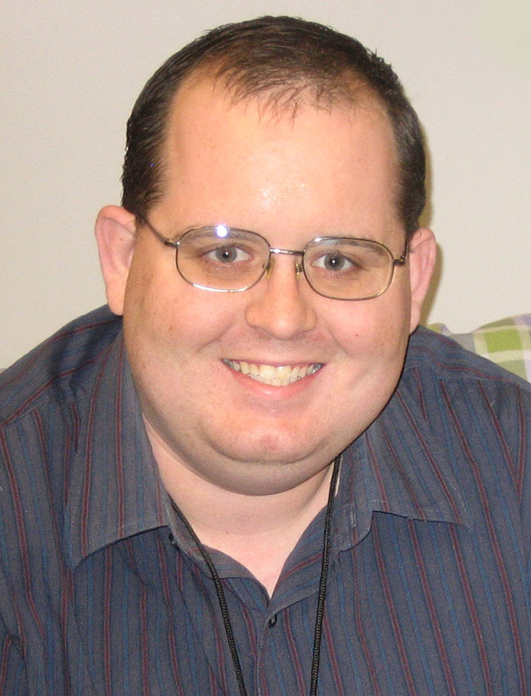
KYEA is creating a new peer group for high school students with disabilities and with a new program comes a new addition to the KYEA staff team. Zachariah Davis recently joined KYEA as our new Peer Support Assistant. He will be working with other staff to create, recruit, and facilitate this new peer group in Topeka.

Zach grew up in Michigan Valley, KS, and then lived in Kansas City for many years. He moved to Topeka three years ago. Zach has had a variety of work experiences, including time spent at the Wyandot Center in Kansas City, Keys for Networking, and some work experience with the University of Kansas. Although he has worked for a variety of places, he is still making an effort to really build his work experience. Zach sees coming to KYEA as a great opportunity to build on his skills, while also doing something that he loves. When not at work, Zach enjoys playing with his cat, listening to music, and is currently learning to play the bass guitar.

Zach has enjoyed his time at KYEA so far. He states, "It's been the most positive job environment I've ever been in." Welcome aboard Zach!

A new peer support group for high school students with disabilities will be forming in Topeka and will start in early 2010. This group will assist the youth participants in exploring employment topics and goals, and will give them the opportunity to learn from each other, as well as an adult mentor. If you are a high school sophomore or junior with a disability who is interested in participating in this group, please contact Zach at 785-215-6655 or peersupport@kyea.org.

Disability Awareness and History Bill in Kansas enters new stages of development
When the Disability Awareness and History Bill passed in our state during the last legislative session, we all celebrated. After the celebration came the realization that we now have large possibilities in front of us. The large question was, where do we go from here? This question has been answered in recent months.

After the passage of this bill, KYEA began brainstorming ways to help schools implement this new legislation in the classrooms. We started by creating a CIL Liaison program to select one person in each independent living center that will create connections in local schools. These liaisons will be working with their schools to assist teachers in following through on the bill.

KYEA has also been working very closely with the Kansas State Department of Education in the last few months. KSDE and KYEA, along with the Kansas Commission on Disability Concerns and Families Together, are currently working to create a resource manual that will be given to teachers across Kansas. This manual will guide teachers in their efforts to bring disability awareness and history into their classrooms.

And, for one of the most exciting pieces of news... a couple of months ago, the State Board of Education wrote a proclamation to designate the third week of October as Disability History and Awareness Week in Kansas! Schools will be encouraged during this week, each year, to teach disability education to all students. Exciting things are happening in our state!

Needed: Youth with healthcare needs to serve on committee
Are you a youth with special healthcare needs? Would you like to contribute your input on a committee? Then your voice is needed on the Systems In Sync Stakeholder Committee!

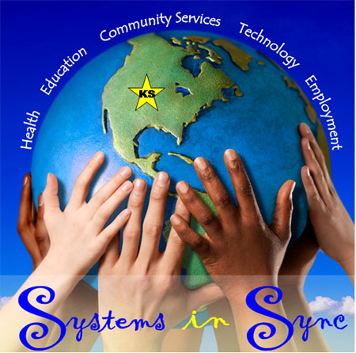
KYEA is working with KDHE's Department for Children and Youth with Special Healthcare Needs to find young people with disabilities in Kansas who deal with chronic health conditions on a daily basis. Their stakeholder committee is looking to recruit more youth members who have thoughts and opinions to share on healthcare for young people. As a committee member, participants are asked to attend meetings and provide feedback from the youth perspective. If you have something to say about health, doctor's visits, and your experiences, then this is your chance to share it.

If you would like more information about serving on this committee, contact Carrie at 785-215-6655 or carrieg@kyea.org.

If you have ideas and feedback, but do not have time to serve on a committee, then attend an upcoming town hall meeting at a location near you. These local forums will serve as an opportunity to hear from the community about issues facing youth with healthcare needs. The dates and locations are below:

Tues., February 2- Colby, Colby Community Building
Wed., February 3- Hays, Sternberg Museum
Mon., February 8- Garden City, Center for Independent Living
Tues., February 9- Liberal, Liberal Memorial Library
Mon., February 15- Wichita, Independent Living Resource Center
Tues., February 16- Independence, SRS Center
Mon., February 22- Kansas City, Roeland Park Community Center
Wed., February 24- Topeka, Topeka & Shawnee County Public Library

Upcoming Board Meeting Dates
All KYEA board meetings are open to the public, but attendees do not have voting rights during the meeting.
Next board meeting: Saturday, January 9, 2010, at the Exploration Place, 300 N. McLean Blvd, Wichita, KS, at 10:00 am.

FEATURED YOUTH by Carrie Greenwood
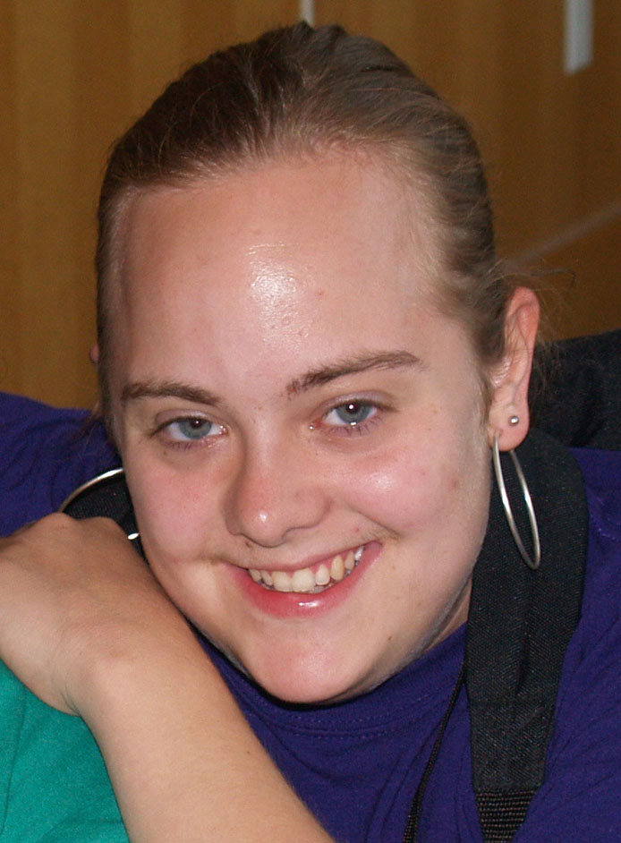
Nicole Swenson- KSYLF Alumni 2003
There is a reason that Nicole Swenson, KSYLF Alumni 2003, won KYEA's Outstanding Youth Leader of the Year Award back in 2005. She sets out to achieve her goals and make a difference in the community. Nicole continues to live this philosophy even today. She is continuing to accomplish her goals and give back to others at the same time.

Nicole graduated from the University of St. Marys last May. She now has a Bachelor of Arts degree in English and Psychology. Recently, Nicole has been working at a place where she can use her people skills and interact with other people with disabilities. She currently works for Riverside Resources, Inc. in Leavenworth. Nicole serves as the receptionist and has such duties as filing, organizing, and other administrative tasks. She has enjoyed working with other people with developmental disabilities.

"I'm making a difference every day with the people that I serve," Nicole said.

Nicole will be enrolling in the American Sign Language program at Johnson County Community College and will start classes in January. Attending KSYLF sparked her interest in working with people with disabilities, and now she is branching out to eventually work with the deaf community. Nicole has other goals set for the future, which include meeting up with one of her best friends that lives in Connecticut. As a budding writer, her goal for 2010 is to write a book and get it published by the end of the year.

Keep moving forward Nicole... we are very proud of you!

Are you a Kansas youth with a disability who has a story to share? We are always eager to hear about youth who are active in their communities! Send us your stories and we will publish YOU in future issues of our e-newsletter. Give us a call or send us an email... let us know all about your accomplishments! Contact KYEA at 785-215-6655 or carrieg@kyea.org.

QUESTION OF THE MONTH
What is the best Christmas gift that you have ever received?
Cole Mills, KSYLF Alumni 2002
"The best Christmas gift that I received was a Nintendo 64! It was the coolest thing that I have ever seen. My parents could not find me for four weeks. I was glued to the Nintendo 64."
Shannon Cox, KYEA Administrative Assistant
"Fifty dollars from Santa!! There really is a Santa."

Amber Dipman, KYEA Office Volunteer
"The best Christmas gift I have ever received is a Wii video game system I got from my brother before he was deployed to Kuwait."

Dayna Rucker, KSYLF Alumni 2009
"The best Christmas present I ever received was my stuffed animal dog named Patrick. I was a lot younger when I received him, but I loved him so much and appreciated him very much. I still have him today, for seven years, thanks to my grandma and grandpa. I appreciate them very much."

Anne-Marie Hughey, KYEA Board Member
"A sapphire ring, when I was 13, from my mom and dad. It was the birthstone of my older brother who I was very close to who died earlier that year."

JoAnne Fluke, KYEA VISTA Fundraising Coordinator
"The Christmas that I was in the hospital, my dad and brother gave me a raincheck on Christmas so that we could all celebrate at home as a family."

Brian Ramsey, KSYLF Volunteer
"I would have to say my best present was an original Nintendo."

Santa Claus, Friend of KYEA
"Milk and cookies!!"

STATE NEWS

There is a lot going on in Kansas. See the latest news below. Visit each link to get more information.

Families Together to host "Together We Can Learn" conference in Topeka - - www.familiestogetherinc.org

Transition conference in Kansas City, hosted by Families Together, rescheduled for February - - www.familiestogetherinc.org

New resource on transition tips published by KU Transition Coalition - - www.kcdcinfo.com/DocumentView.aspx?DID=584

KDHE announces "Call for Investment" to strengthen partnership between youth and medical providers - - www.kdheks.gov/cyshcn/download/Call-for-Investment-Application.pdf

Healthy Kansans survey seeks input on health issues in the state - - www.surveymonkey.com/s/2H7XQJD

Ms. Wheelchair Kansas searches for women of achievement to serve as contestants - - www.mswheelchairkansas.org

Wheelchair basketball tournament to be held in Lawrence in January - - www.kansasaccessiblesports.com/basketball.html
(follow link and scroll down to Wheelhawk Conf Tournament)
NATIONAL NEWS
There are great opportunities coming up on a national level. Read all about them below. Visit each link to get more information.


Healthy relationships for people with disabilities teleconference series now on CD - - www.hsri.org/leaders/theriot

VSA Arts seeking play scripts about life with a disability from youth - - www.vsarts.org/x244.xml

Many Worlds seeks art on the meaning of disability for online publication - - www.manyworldsnetwork.com

Braille Readers are Leaders contest now open to youth and adults with visual disabilities - - www.nfb.org/nfb/Braille_Readers_Are_Leaders_Overview.asp

National "Kid's Speak Up" conference targets youth with epilepsy - - www.epilepsyfoundation.org/advocacy/events/Kids-Speak-Up

United We Ride addresses topic of access to transportation in the U.S.- - www.uwrdialogue.org

Webinar series to cover social networking, assistive technology, and accessible media - - www.ada-audio.org/Webinar/AccessibleTechnology

Coccia Awards to recognize two females, ages 14 to 17, making positive social change - - http://ysa.org/grants/announcements/coccia-award

SCHOLARSHIP

Loreen Arbus Foundation:
Focus on Disability Scholarship
The Loreen Arbus Foundation, Academy of Television Arts & Sciences Foundation, and the Foundation of American Women in Radio and Television are teaming up to award a $10,000 scholarship to filmmakers with disabilities or to producers who create a film about disability.

This scholarship will recognize student producers who:
- shed light on people with disabilities, the nation's largest minority group
- help emerging artists within this community gain recognition
- increase visibility for artists with disabilities

This award will be given to a writer, producer or director who is disabled, to a producer whose piece focuses on people disabilities, or to a piece that features a person with a disability as one of the main characters.

The first Focus on Disability scholarships will be presented April 10 as part of the ATAS Foundation's annual College Television Awards. The deadline to apply for this scholarship is January 13, 2010. To learn more about the scholarship, visit www.emmysfoundation.org/how-apply-2#newthisyear.
INTERNSHIPS

AAPD Summer Internships in Washington, DC:
Open to college students with disabilities
How would you like to spend your summer working in Washington, DC? The American Association for People with Disabilities is currently searching for qualified college students with disabilities to fill two summer internship positions in Washington, DC. AAPD summer interns receive a living stipend, accessible housing, and travel to and from Washington, DC. Currently-enrolled undergraduate college students with any type of disability pursuing any type of undergraduate degree are encouraged to apply.

The AAPD-MEAF Congressional Internship Program provides students interested in government, politics, law, or leadership the unique opportunity to intern on Capitol Hill for members of Congress. Previous AAPD-MEAF Congressional intern placements have included: Senator Barack Obama, Senator Hilary Clinton, Senator Sam Brownback, Senator Ted Kennedy, and many more.

The AAPD-Microsoft Federal IT Internship Program provides students pursuing careers in Information Technology the unique opportunity to intern in the IT divisions of federal agencies. Previous IT placements have included: US Coast Guard, Department of Homeland Security, US Patent and Trade Office, National Science Foundation, US Department of Transportation, and more.

The application deadline for these internships is January 8, 2010. For more information, visit www.aapd.com/AAPDInternship or contact David Hale at 202-521-4305 or dhale@aapd.com.

White House Fellows Program:
Offered to accomplished, motivated young adults
The White House Fellows program is one of America's most prestigious programs for leadership and public service. White House Fellowships offer exceptional young men and women first-hand experience working at the highest levels of the federal government.

Selected individuals typically spend a year working as a full-time, paid Fellow to senior White House Staff, Cabinet Secretaries and other top-ranking government officials. Fellows also participate in an education program consisting of roundtable discussions with renowned leaders from the private and public sectors, and trips to study U.S. policy in action both domestically and internationally. Fellowships are awarded on a strictly non-partisan basis.

Selection as a White House Fellow is based on a combination of the following criteria:
- A record of remarkable professional achievement early in one's career.
- Evidence of leadership skills and the potential for further growth.
- A demonstrated commitment to public service.
- The skills to succeed at the highest levels of the Federal government, and the
ability to work effectively as part of a team.

All these qualities combined with the strength of one's character, a positive attitude, and the ability to work well with others are taken into consideration when selecting a class of White House Fellows. All applications must be submitted by February 1, 2010. For more information, visit www.whitehouse.gov/about/fellows.

Pitt and Carnegie Mellon Internships: Open to undergraduate students interested in assistive technology
Pitt and Carnegie Mellon are currently recruiting for their summer undergraduate research internships. Both internships involve researching assistive technology and devices designed to benefit individuals with disabilities. The best part is, these internships offer an inclusive environment for students with disabilities.

The American Student Placements in Rehabilitation Engineering (ASPIRE) program focuses on research in the rehabilitation engineering and assistive technology fields. Interns will learn about the design, modification, customization and/or fabrication of assistive technology for persons with disabilities. The Quality of Life Technology Engineering Research Center (QoLT ERC) program teaches students about technology and engineering, as well as gives them an understanding of the design of intelligent devices and systems that aid and interact with people.

Both programs offer the following: a competitive stipend, free ACCESSIBLE housing, travel money, support for students to attend a conference the following year, innovative research projects, hands-on workshops, and fun social events and networking opportunities. All internship applications are due on February 15, 2010. To learn more about this internship, visit www.herlpitt.org/internships.

QUOTE OF THE MONTH
"When was the last time you did something for the first time?"
- Sally Edwards
Thank you for all of the support that you have shown to KYEA in the past year. A whole new year is right around the corner, and we look forward to working with all of you in 2010! We also leave you with the challenge to make this the best year ever.

Happy Holidays and Happy New Year!

Sincerely,

KYEA Staff
Julia, Carrie, Shannon, JoAnne, and Zach

Kansas Youth Empowerment Academy | PO Box 475 | Topeka | KS | 66601

